June 2017

DRAFT

Child Care in Yolo County
Findings from the 2017 Local Child Care Planning Council Needs Assessment

The purpose is to understand, document, and respond to the child care needs in Yolo County.
Data sources include California Department of Education, Child Welfare, U.S. Census, and Community Care Licensing.

- Most recent year available for data sources varied from 2014 to 2017

- Age breakdowns for this assessment are: 0-2, 3- 4, and 5-12 year olds

- Providers who are not licensed (e.g., family, friends, and neighbors) are not included in this assessment

- Child care slots in a particular city may be filled by families who do not live in that city

- Most city data are estimates

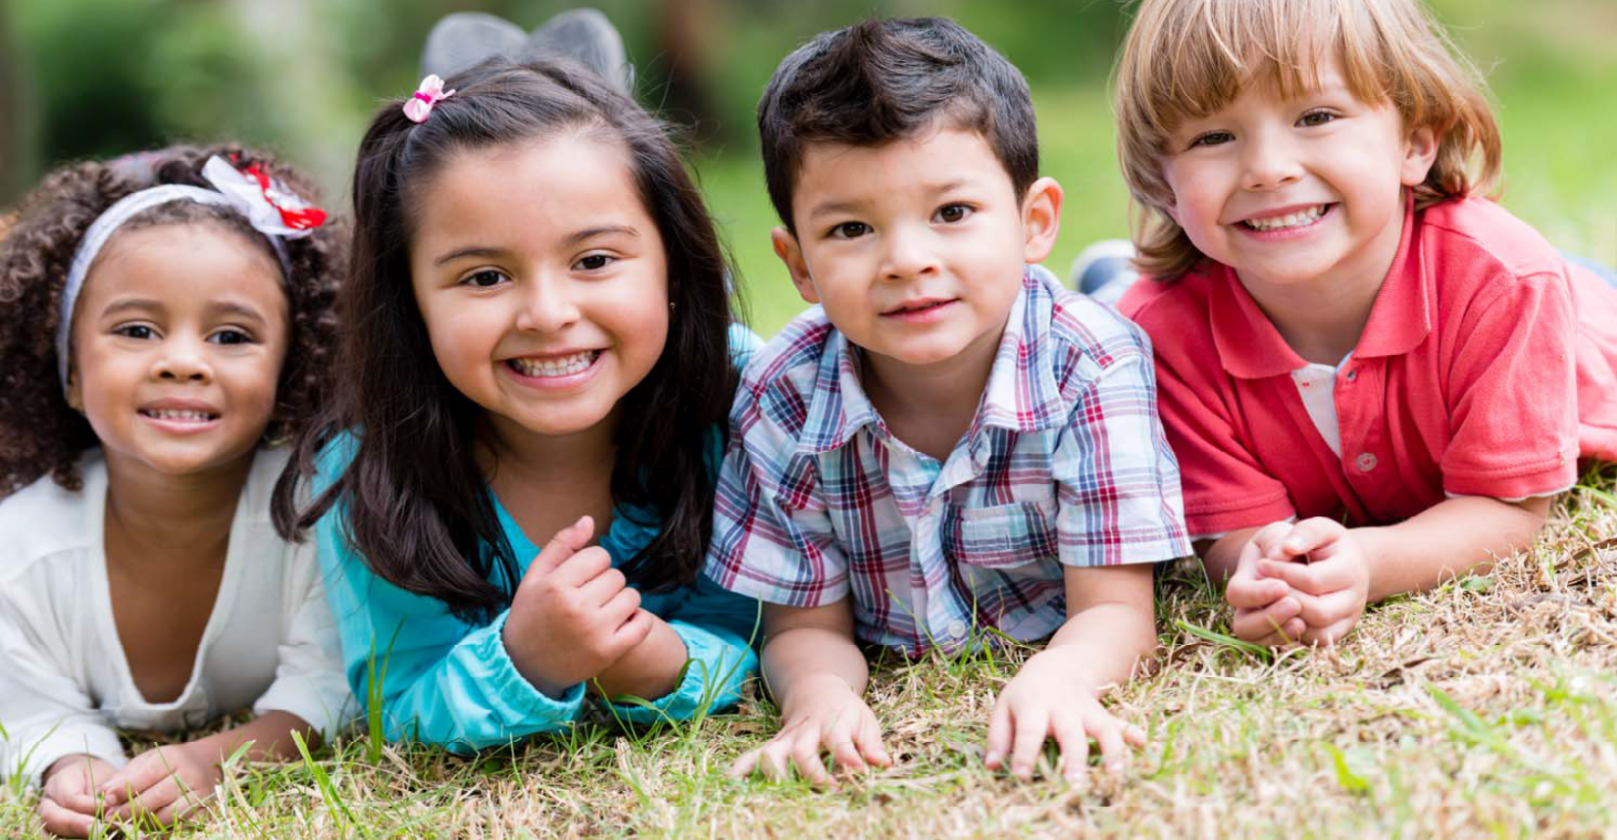

Child and Family Characteristics

Child Population in Yolo County, by Age Group

 | # | of Children
0-2 Years Old |  | 7,005
3-4 Years Old |  | 5,233
5-12 Years Old |  | 20,385
Total |  | 32,623

Child Population in Yolo County, by Age Group and City

0-2
Years Old
Davis | 2,586
West Sacramento | 1,709
Winters | 286
Woodland | 2,088
Rural Yolo | 336
Yolo County | 7,005

Child Population in Yolo County, by Age Group and City

0-2
Years Old
3-4

Years Old

Davis 2,586 1,931

West Sacramento 1,709 1,278
Winters 286 212
Woodland 2,088 1,560
Rural Yolo 336 252
Yolo County 7,005 5,233

Child Population in Yolo County, by Age Group and City

 | 0-2  Years Old | 3-4  Years Old | 5-12  Years Old
Davis | 2,586 | 1,931 | 7,528
West Sacramento | 1,709 | 1,278 | 4,974
Winters | 286 | 212 | 842
Woodland | 2,088 | 1,560 | 6,075
Rural Yolo | 336 | 252 | 966
Yolo County | 7,005 | 5,233 | 20,385

Child Population in Yolo County, by Age Group and City

 | 0-2  Years Old | 3-4  Years Old | 5-12  Years Old | Total
Davis | 2,586 | 1,931 | 7,528 | 12,045
West Sacramento | 1,709 | 1,278 | 4,974 | 7,961
Winters | 286 | 212 | 842 | 1,340
Woodland | 2,088 | 1,560 | 6,075 | 9,723
Rural Yolo | 336 | 252 | 966 | 1,554
Yolo County | 7,005 | 5,233 | 20,385 | 32,623

Race/Ethnicity of Children K-12 in Yolo County (n=29,841)

Percent

Hispanic or Latino 47%

White, Not Hispanic 35%

Asian American 10%

African American 3%

Pacific Islander 2%

American Indian or Alaskan Native 1%

Multiracial/ethnic 3%

Language of Children K-12 in Yolo County (n=6,344)

Percent

Spanish 74%

Russian 7%

Punjabi 4%

Korean 2%

Mandarin 2%

Urdu 1%

Other 10%

Children with an IFSP/IEP in Yolo County, by Age Group

# of Children in Yolo County
0-2 Years Old (IFSP) 50
3-4 Years Old (IEP) 295
5-12 Years Old (IEP) 1,966
Total 2,311

Children Served in Child Protective Services (CPS) in Yolo County, by Age Group

# of Children in CPS System
# of Children in CPS System Referred for Child Care

0-2 Years Old 99 13

3-4 Years Old 60 13

5-12 Years Old 167 3

Total 326 29

Children Ages 0-2 in Yolo County, by Income Level and City

 | At or Below Federal Poverty Level | At or Below 70% State Median Income | Above 70% State Median Income
Davis | 253 | 569 | 2,017
West Sacramento | 386 | 697 | 1,012
Winters | 27 | 115 | 171
Woodland | 482 | 743 | 1,345
Rural Yolo | 259 | 251 | 85
Yolo County | 1,408 | 2,375 | 4,630

Children Ages 3-4 in Yolo County, by Income Level and City

 | At or Below Federal Poverty Level | At or Below 70% State Median Income | Above 70% State Median Income
Davis | 189 | 425 | 1,506
West Sacramento | 289 | 521 | 757
Winters | 20 | 85 | 127
Woodland | 360 | 555 | 1,005
Rural Yolo | 194 | 187 | 65
Yolo County | 1,052 | 1,774 | 3,459

Children Ages 5-12 in Yolo County, by Income Level and City

 | At or Below Federal Poverty Level | At or Below 70% State Median Income | Above 70% State Median Income
Davis | 753 | 1,656 | 5,872
West Sacramento | 1,234 | 2,029 | 2,945
Winters | 49 | 338 | 504
Woodland | 1,087 | 2,163 | 3,912
Rural Yolo | 506 | 725 | 241
Yolo County | 3,629 | 6,911 | 13,474

Children Ages 0-21 in Migrant Families (50% or more of income is from migrant work) in Yolo County, by City

# of Children in Migrant Families
Davis 127
West Sacramento 0
Winters 132
Woodland 333
Rural Yolo 188

Yolo County 780

Child Care Demand

Number of Children with All Parents in the Workforce in Yolo County, by Age Group and City

 | 0-2  Years Old | 3-4  Years Old | 5-12  Years Old | Total
Davis | 1,548 | 1,236 | 5,172 | 7,956
West Sacramento | 1,021 | 816 | 3,412 | 5,249
Winters | 179 | 142 | 586 | 907
Woodland | 1,248 | 998 | 4,169 | 6,415
Rural Yolo | 200 | 161 | 657 | 1,018
Yolo County | 4,196 | 3,353 | 13,996 | 21,545

Number of Children in Families with Working Parents who are at or Below 70% SMI, by Age Group and City

0-2
Years Old
3-4

Years Old
5-12

Years Old

Total

Davis 542 425 1,925 2,892

West Sacramento 357 279 1,270 1,906

Winters 62 49 212 323
Woodland 437 342 1,552 2,331
Rural Yolo 78 57 256 391
Yolo County 1,476 1,152 5,215 7,843
Number of 3 & 4 year olds with at least one non-working parent (all income levels), by City
Total
Davis 695
West Sacramento 462
Winters 70
Woodland 562
Rural Yolo 91
Yolo County 1,880
Number of 3 & 4 year olds with at least one non-working parent in a family at or below 70% SMI, by City
Total
Davis 153
West Sacramento 188
Winters 28
Woodland 200
Rural Yolo 67
Yolo County 636

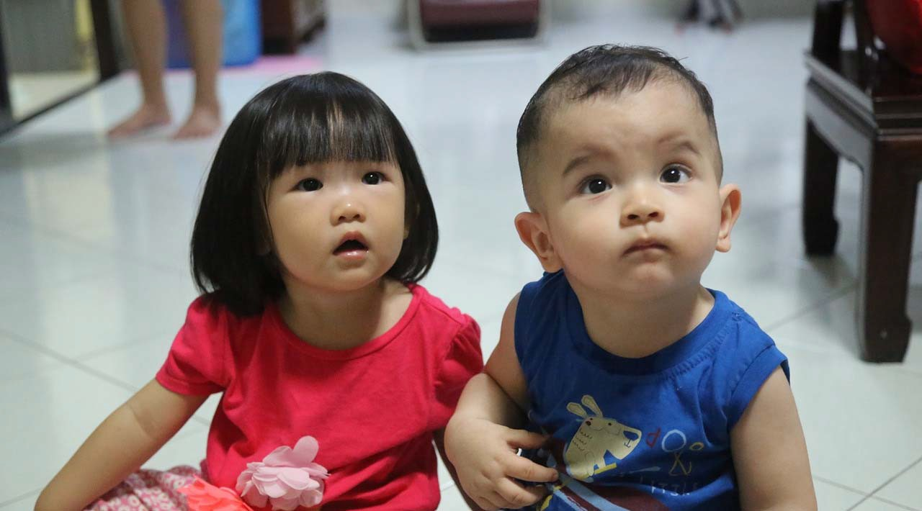

Child Care Capacity

Licensed Child Care Capacity in Yolo County, by Type of Care, Age Group, and City

Child Care Centers

 | 0-2  Years Old | 3-4  Years Old | 5-12  Years Old
Davis | 109 | 1,523 | 754
West Sacramento | 51 | 526 | 208
Winters | 24 | 174 | 45
Woodland | 118 | 1,072 | 365
Rural Yolo | 60 | 237 | 30
Yolo County | 362 | 3,532 | 1,402

Licensed Child Care Capacity in Yolo County, by Type of Care, Age Group, and City

Child Care Centers Family Child Care Homes

 | 0-2  Years Old | 3-4  Years Old | 5-12  Years Old | 0-2  Years Old | 3-4  Years Old | 5-12  Years Old
Davis | 109 | 1,523 | 754 | 189 | 150 | 97
West Sacramento | 51 | 526 | 208 | 485 | 385 | 249
Winters | 24 | 174 | 45 | 22 | 18 | 11
Woodland | 118 | 1,072 | 365 | 344 | 273 | 176
Rural Yolo | 60 | 237 | 30 | 33 | 27 | 17
Yolo County | 362 | 3,532 | 1,402 | 1,073 | 853 | 550

Licensed Child Care Capacity in Yolo County, by Type of Care, Age Group, and Year

 | Child  2013 | Care | Centers  2017
0-2 Years Old | 280 |  | 362
3-4 Years Old | 3,406 |  | 3,532
5-12 Years Old | 1,365 |  | 1,402
Total | 5,051 |  | 5,296

Licensed Child Care Capacity in Yolo County, by Type of Care, Age Group, and Year

 | Child  2013 | Care | Centers  2017 | Family Child  2013 | Care Homes  2017
0-2 Years Old | 280 |  | 362 | 1,178 | 1,073
3-4 Years Old | 3,406 |  | 3,532 | 936 | 853
5-12 Years Old | 1,365 |  | 1,402 | 604 | 550
Total | 5,051 |  | 5,296 | 2,718 | 2,476

Licensed Child Care Capacity for Children Ages 0-2 in Yolo County, by Type of Care, City, and Year

Child Care Centers 2013 2017
Davis 103 109
West Sacramento 47 51
Winters 0 24
Woodland 70 118
Rural Yolo 60 60
Yolo County 280 362

Licensed Child Care Capacity for Children Ages 0-2 in Yolo County, by Type of Care, City, and Year

 | Child  2013 | Care | Centers  2017 | Family Child  2013 | Care Homes  2017
Davis | 103 |  | 109 | 231 | 189
West Sacramento | 47 |  | 51 | 523 | 485
Winters | 0 |  | 24 | 44 | 22
Woodland | 70 |  | 118 | 352 | 344
Rural Yolo | 60 |  | 60 | 28 | 33
Yolo County | 280 |  | 362 | 1,178 | 1,073

Licensed Child Care Capacity for Children Ages 3-4 in Yolo County, by Type of Care, City, and Year

 | Child  2013 | Care | Centers  2017
Davis | 1,452 |  | 1,523
West Sacramento | 488 |  | 526
Winters | 129 |  | 174
Woodland | 1,134 |  | 1,072
Rural Yolo | 203 |  | 237
Yolo County | 3,406 |  | 3,532

Licensed Child Care Capacity for Children Ages 3-4 in Yolo County, by Type of Care, City, and Year

 | Child  2013 | Care | Centers  2017 | Family Child  2013 | Care Homes  2017
Davis | 1,452 |  | 1,523 | 184 | 150
West Sacramento | 488 |  | 526 | 415 | 385
Winters | 129 |  | 174 | 35 | 18
Woodland | 1,134 |  | 1,072 | 280 | 273
Rural Yolo | 203 |  | 237 | 22 | 27
Yolo County | 3,406 |  | 3,532 | 936 | 853

Licensed Child Care Capacity for Children Ages 5-12 in Yolo County, by Type of Care, City, and Year

Child Care Centers 2013 2017
Davis 752 754
West Sacramento 207 208
Winters 45 45
Woodland 277 365
Rural Yolo 84 30
Yolo County 1,365 1,402

Licensed Child Care Capacity for Children Ages 5-12 in Yolo County, by Type of Care, City, and Year

 | Child  2013 | Care | Centers  2017 | Family Child  2013 | Care Homes  2017
Davis | 752 |  | 754 | 119 | 97
West Sacramento | 207 |  | 208 | 268 | 249
Winters | 45 |  | 45 | 23 | 11
Woodland | 277 |  | 365 | 180 | 176
Rural Yolo | 84 |  | 30 | 14 | 17
Yolo County | 1,365 |  | 1,402 | 604 | 550

Child Care Costs

Weekly Maximum Regional Market Rates for Child Care in Yolo County, by Type of Care and Age Group

Child Care Centers

0-2
Years Old
3-4
Years Old
5-12
Years Old

Full-time care $366 $305 $203 Part-time care $271 $241 $138

Weekly Maximum Regional Market Rates for Child Care in Yolo County, by Type of Care and Age Group

Child Care Centers Family Child Care Homes

 | 0-2 | 3-4 | 5-12 | 0-2 | 3-4 | 5-12
 | Years | Years | Years | Years | Years | Years
 | Old | Old | Old | Old | Old | Old
Full-time care | $366 | $305 | $203 | $213 | $192 | $163
Part-time care | $271 | $241 | $138 | $160 | $189 | $128

Children Enrolled in State and Federal Child Care Subsidy Programs

Children Served in Subsidized Child Care in Yolo County (point in time), by Program Type and City

Davis West Sac
Winters Wood-
land
Rural Yolo
Yolo County

Full-Day Center 40 16 0 98 19 173
State Preschool 29 222 42 180 48 521
Migrant 2 7 0 13 55 77
Alternative Payment 12 30 3 25 31 101
CalWORKs | Stage | 1 | 39 | 122 | 4 | 99 | 17 | 281
CalWORKs | Stage | 2 | 10 | 43 | 1 | 36 | 31 | 121
CalWORKs | Stage | 3 | 6 | 54 | 0 | 39 | 12 | 111
Head Start |  |  | 32 | 54 | 0 | 94 | 24 | 204
Early Head | Start |  | 0 | 27 | 0 | 11 | 0 | 38
Other |  |  | 6 | 0 | 0 | 0 | 0 | 6

Child Care in Yolo County: Findings from the 2017 Needs Assessment

June 2017 39

Children Served in Subsidized Child Care in Yolo County, by Type of Care and Year

2013 2017
Full-Day Center 147 173
State Preschool 862 521
Migrant 135 77
Alternative Payment 127 101

Child Care i 40

n Yolo County: Findings from the 2017 Need

s Assessment June 2017
CalWORKs | Stage | 1 | 212 | 281
CalWORKs | Stage | 2 | 207 | 121
CalWORKs | Stage | 3 | 117 | 111
Head Start |  |  | 330 | 204
Early Head | Start |  | 97 | 38
Other |  |  | 152 | 6
TOTAL |  |  | 2,,386 | 1633

Unmet Need

Full-Time Child Care Needs for Working Parents in Yolo County

21,545
13,761
Deficit

7,784

Children with all parents in the workforce
Full-time licensed slots available

Full-Time Child Care Needs for Working Parents in Yolo County, by Age Group and City

 | 0-2  Years Old | 3-4  Years Old | 5-12  Years Old | Total
Davis | -81% | 35% | -84% | -65%
West Sacramento | -47% | 12% | -87% | -63%
Winters | -74% | 35% | -90% | -68%
Woodland | -63% | 35% | -87% | -63%
Rural Yolo | -54% | 64% | -93% | -60%
Yolo County | -66% | 31% | -86% | -64%

Full-Time Child Care Needs for Working Parents Eligible for State Subsidy in Yolo County

7,843
6,210
Deficit

1,633

Children eligible for state subsidy with all parents in
the workforce
Subsidized slots available

Full-Time Child Care Needs for Working Parents Eligible for State Subsidy in Yolo County, by Age Group and City

 | 0-2  Years Old | 3-4  Years Old | 5-12  Years Old | Total
Davis | -97% | -87% | -96% | -95%
West Sacramento | -72% | -37% | -89% | -78%
Winters | -98% | -94% | -98% | -98%
Woodland | -85% | -45% | -88% | -81%
Rural Yolo | 38% | 28% | -88% | -46%
Yolo County | -80% | -22% | -92% | -79%

Part-Time Preschool Needs for Preschool-Age Children with At Least One Parent at Home (All Incomes)

1,880
1,461
Deficit

419

3 & 4 yr olds with at least 1
non-working parent
Part-time preschool slots available

Part-Time Preschool Needs for Preschool-Age Children with At Least One Parent at Home (Eligible for State Subsidy)

637

419
218
Deficit

3 & 4 yr olds eligible for state subsidy
with at least 1 non-working parent
Part-time subsidized preschool
slots available

Half-Day Preschool Available to Preschool-Age Children in Families with At Least One Parent at Home

All Incomes Eligible for
State Subsidy

Davis 96% 81%

West Sacramento 68% 21%

Winters 40% -50%

Woodland 69% 12%

Rural Yolo 74% 64%

Yolo County 78% 34%

  - What stands out?

  - What questions do you have?

  - What opportunities do you see for action?

